15 Sept 2025 Sports Report

*Devin Wasilefsky*

**QB Draft Stats**

1. Possible story lines
   1. Drafted QBs still rule
      1. Across 2000–2024, teams with drafted QBs are more likely to make the playoffs (45% vs 34%) and much more likely to reach the Super Bowl (8% vs 4%).

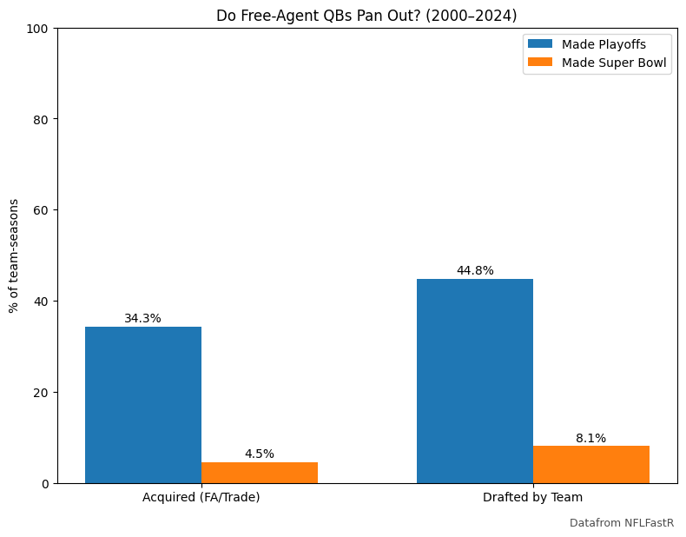

Figure 1: Playoff/SB vs QB Type

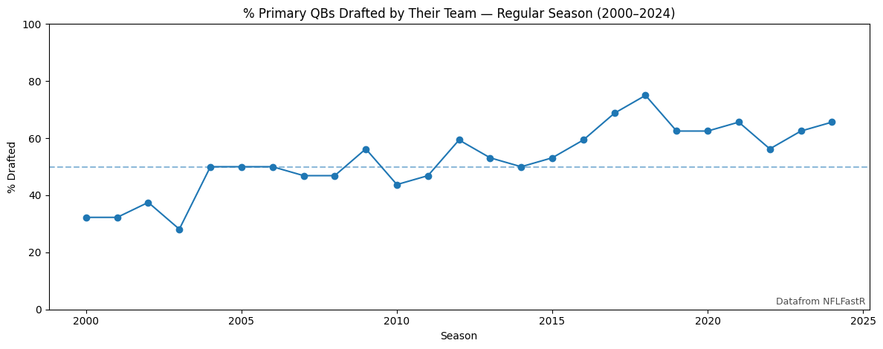

Figure 2: Share of Primary QBs Drafted by Their Team

* 1. Free-agent bumps are rare
     1. Acquired quarterbacks occasionally break through (think Peyton Manning in Denver, Tom Brady in Tampa), but over the long run, they’re half as likely to deliver Super Bowl appearances.
  2. Recent years echo the trend
     1. From 2020–24, the playoff gap widened slightly (48% vs 40%), while Super Bowl odds remained firmly in favor of drafted QBs (8% vs 4%).
  3. Shorter leash for free agents
     1. Tenure analysis shows acquired QBs average only ~1.6 consecutive seasons as a team’s primary starter since 2020, compared to ~2.1 for drafted QBs. Over the full 2000–24 window, drafted QBs last longer as well (3.3 vs 3.0 years).
  4. QB Development Window Decreasing
     1. QB start to bench has decreased significantly since 2000 with a p-value of 0.0066 (slope is negative!).

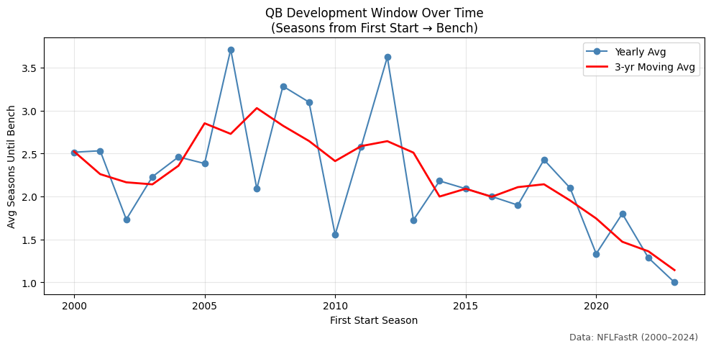

Figure 3: QB Development Window

1. Caveats & Methodology Notes
   1. **Data coverage:** Play-by-play and player metadata from **NFLFastR (2000–2024)** were used to identify starting quarterbacks and link them to draft information.
   2. **Defining starters:** The “primary starter” for each team-season was defined as the quarterback with the most pass attempts. For playoffs and Super Bowls, the starter was taken from the team’s first playoff game or Super Bowl appearance.
   3. **Draft linkage:** Draft team and year were pulled from NFL player tables and supplemented with manual corrections for older players (early 2000s).
   4. **Analysis scope:** Results focus only on team-seasons where the quarterback’s draft origin could be confidently established; seasons with missing or ambiguous draft data were excluded.
   5. **Interpretation:** Probabilities represent the share of team-seasons that reached the playoffs or Super Bowl given the QB’s origin. These are descriptive comparisons rather than causal claims.
2. Key Stats
   1. Sample size:
      1. 688 total team-seasons with known QB draft status (2000–2024).
      2. Drafted QBs: 420; Acquired QBs: 268.
   2. Playoff probability:
      1. Drafted QBs: 44.8% (95% CI 40–50)
      2. Acquired QBs: 34.3% (95% CI 29–40)
   3. Super Bowl probability:
      1. Drafted QBs: 8.1% (95% CI 6–11)
      2. Acquired QBs: 4.5% (95% CI 3–8)
   4. Recent window (2020–24):
      1. Drafted QBs: Playoffs 48%, Super Bowl 8%
      2. Acquired QBs: Playoffs 40%, Super Bowl 4%
   5. Tenure (consecutive seasons as primary QB):
      1. Drafted QBs: Mean 3.3 (2000–24), 2.1 (2020–24)
      2. Acquired QBs: Mean 3.0 (2000–24), 1.6 (2020–24)
   6. Since 2000, 52.6% of QBs have been drafted by their own team
   7. Playoff starting QBs drafted by their team (2000-2024)
      1. 59% overall
         1. 2000s: 43.3%
         2. 2010s: 69.2%
         3. 2020s: 68.6%
   8. Super Bowl starting QBs drafted by their team (2000-2024)
      1. 68% overall
         1. 2000s: 50%
         2. 2010s: 80%
         3. 2020s: 80%
3. Conclusion
   1. The myth of the free-agent savior QB is largely overstated. While outliers like Brady and Manning prove it can happen, the broader trend is clear: **teams are more likely to win with quarterbacks they draft and develop.** Drafted QBs give teams both **better odds of postseason success and longer stability under center.** Acquired quarterbacks can plug short-term holes, but they rarely pan out as lasting solutions or Super Bowl ticket-punchers.